LABORATORY WORK
STUDY OF MUTUAL SOLUBILITY IN A THREE-COMPONENT SYSTEM

The mutual solubility of liquids in each other can be quite different. Liquids could be mixed(dissolved) with each other in any ratio and it may be difficult to determine used solutions.
For example, one liquids are soluble in one another(water-acetone and water-alcohol); other liquids are practically insoluble in each other( water and benzene), due to their nature.
Mutual solubility of 3rd type of liquids is limited. Such systems are characterized by the fact that in a certain range of temperature and concentration two mixed liquids in solution break up into two liquid layers.

The curve that limits the dependence on the properties of the system.
Binodal curve can pass through the maximum. In this case, we are dealing with higher critical temperature. For example, mixture with phenol and water. When it passes through a minimum – the system has lower critical temperature, for example, triethyl and water(?). Less common example is presence of both upper and lower critical solubility temperatures, for example, water and nicotine in mixture.
A straight line connecting two points of binodal curve at a constant temperature is called a node. These two points correspond to the compositions of 2 equilibrium phases at given temperature. Therefor, in order to determine the compositions of 2 equilibrium phases in system, it is enough to draw straight line parallel to x-axis at a required temperature value and form intersection between new line with curve.

Within an increase in temperature, the mutual solubility of limited soluble liquids changes in different ways. If system has upper critical temperature, then increase in T contributes to increase in the mutual solubility of components (fig 2). If system has lower critical temperature, then the mutual solubility of components increases with decrease in T (opposite to upper).

Fig1 Change in the mass of the layers when the composition of the mixture changes.
Fig2 The effect of temperature on the mutual solubility of the system with upper critical T
Fig3 The effect of temperature on the mutual solubility of the system with lower critical T
Fig4 Determination of the critical temperature and critical composition by the Alekseev method.

At temperature equal to the lower critical solubility temperature and below, liquids dissolve in each other indefinitely. (fig 3)
To find the critical temperature and the critical composition of the system, the half-diameter Alekseev rule is used. A number of nodes are carried out(preferably at the same T intervals), each node is divided in half and a smooth curve is drawn through the middle of nodes to intersect with the curve. The coordinates of the intersection point will give critical T and critical composition. (fig 4)

Purpose of work: construction of a solubility diagram.
Experimental tasks: 1) determination of mutual solubility of three liquids; 2) determination of the compositions of conjugated solutions; 3) position determination critical point.
Laboratory equipment: Test tubes with ground stoppers - 8 pcs., Burettes - 3 pcs., 50 ml separating funnel, conical flasks with ground stoppers for 30-50 ml - 2 pcs.
Reagents:
A - acetone, methyl alcohol, ethyl alcohol, acetic acid, dioxane;
B - benzene, toluene, xylene, chloroform, CC14;
C - water.

Work progress:
Solubility is determined by titration of homogeneous mixtures of two liquids of different composition with the third component. Titration is carried out until the solution becomes cloudy (while it is necessary to ensure that the solution is not over-titrated); the appearance of turbidity indicates formation of the second phase (transition of the system from a homogeneous state to a heterogeneous one).
Conduct two series of experiments: titration of mixtures A and B with substance C and mixtures A and C - substance B (as instructed by the teacher). You should start compiling a set of two-component mixtures A-B and A-C in the following volumetric ratio: 30:70, 45:55, 60:40, 70:30, 80:20, 85:15, 90:10 and 95:5 ... The number of milliliters B and A (A and C) in each mixture should be calculated so that the total is always 5 ml (A + B = 5 ml).
For this, each liquid is poured into a separate burette.
First, a first series of mixtures (A and B) is made, each of which is taken from the respective burettes into tubes with ground stoppers. These mixtures are titrated with the third component (C). Then mixtures of liquids A and C are made up, which are titrated with substance B.

The results of the experiments are recorded in the following table:
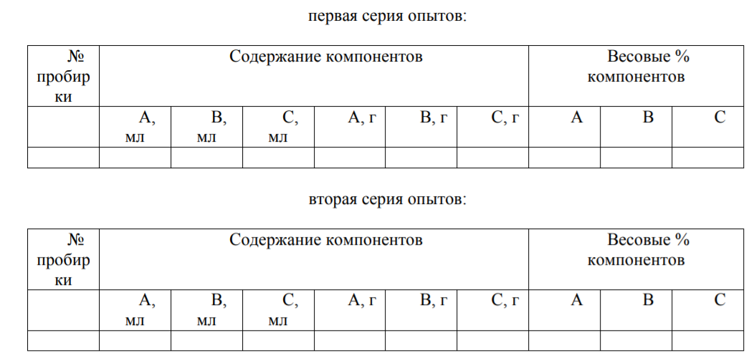

Then milliliters are converted into grams of components (through the density of liquids) and the weight percentages of each component in the mixtures are determined. Based on the obtained percentages of the components, a curve of the solubility of the ECD (Fig. 2) is plotted using a template on an equilateral triangle with a previously drawn scale grid.

Determination of the composition of conjugated solutions and the position of the critical point.

Prepare in a conical flask with a ground stopper 25 g of a mixture of A, B and C, the composition of which should lie in the region of limited solubility (under the solubility curve). To do this, select a point (as instructed by the teacher) lying in
the heterogeneous region of the solubility diagram (for example, point P in Fig. 3) and, knowing the percentage of A, B and C at this point, calculate the required amount (in grams) of each of the components to prepare 25 g of the mixture. Then the masses are converted to milliliters and a mixture is prepared by taking each liquid from the burette.

Then, for 15 minutes, the mixture is thoroughly mixed, divided into two layers using a separating funnel, and the weight of the lower and upper layers is determined by weighing on a technical balance.
Knowing the masses of the two layers and the ratio of their masses, using the lever rule, the compositions (or rather the points corresponding to the compositions) of the conjugate phases are determined.
To do this, a ruler with divisions is placed on the diagram so that it passes through the starting point P. Then the ruler is rotated around the point until they are selected
the ratios of the segments (lp and pf) corresponding to the weight ratios of each of the layers; the ratio of the mass of the layer l (for example, the top) to the mass of the layer - f (for example, the bottom)
should be equal to the ratio of the length of the segment pf to the length of the segment lp (the lower layer will be a solution rich in a heavier liquid from B and C, and a solution rich in a less heavy liquid makes up the upper layer). Through the points l and p found in this way, draw a connection, continue until the intersection with the continuation of the BC side. From
the intersection points draw a tangent to the solubility curve and thus determine the composition of the critical point K.

